Analysis for the production of 15 Sheep Breed at Aframano in Ghana

Preamble
Sheep production is the raising and breeding of domestic sheep. Sheep are raised principally for their meat, milk and wool but I intended to raise for marketing. There are two types of sheep; the indigenous West African Dwarf (WAD) (Djallonké/Local) sheep and the long-legged (Sahelian/Foreign) sheep.

Housing
Each goat/sheep require a space of 15.0-20.0 sq. ft. (variable) in the intensive system.
This means that; 15.0sq.ft. ×15 = 225.0sq. ft. or 20.0sq.ft. ×15 = 300.0sq.ft.

A pen for housing sheep.
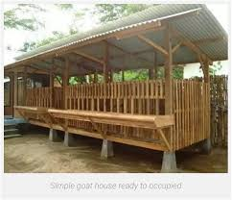

FENCE LAND FOR REARING SHEEP
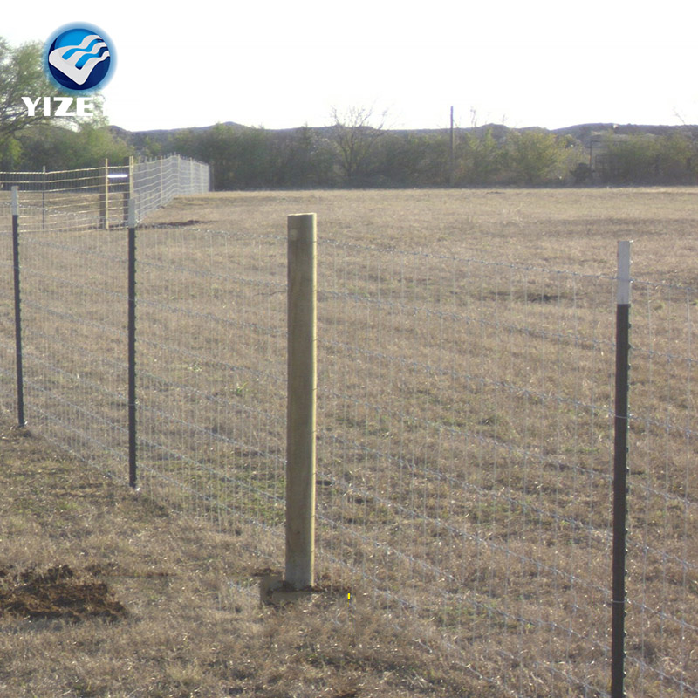

Gimmers/Young Bucks/Young Rams for Selection
Foreign (Sahelian) Breed sheep.
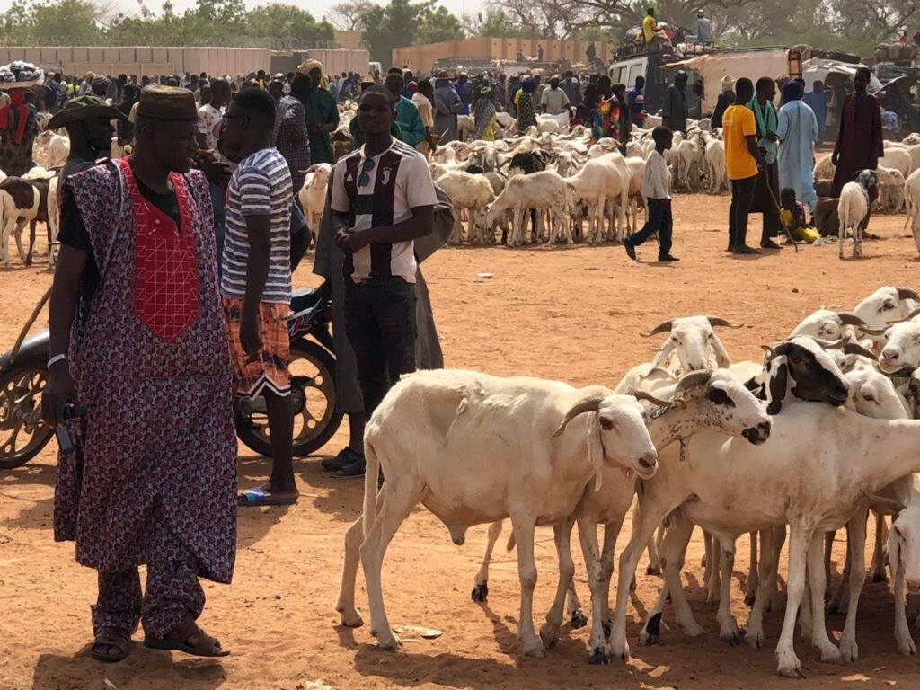

Local (Djallonke) Breed Sheep 15
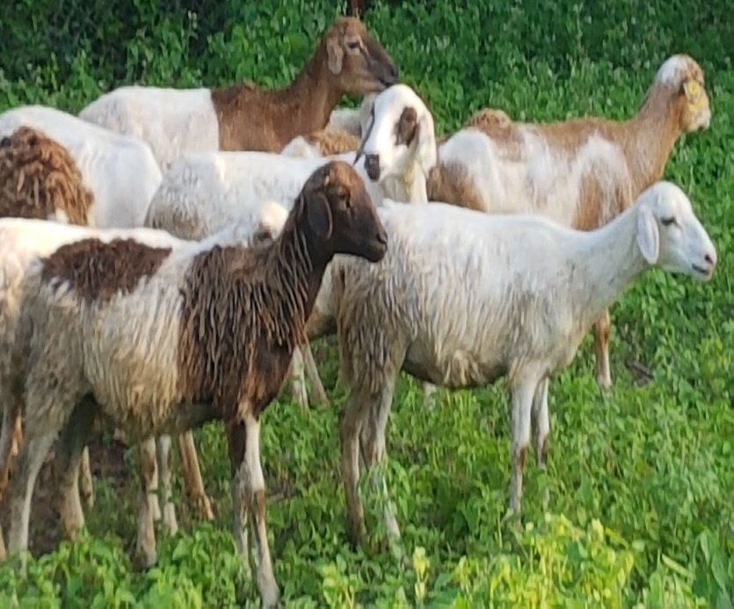

Feeders and drinkers

Feeders Drinkers
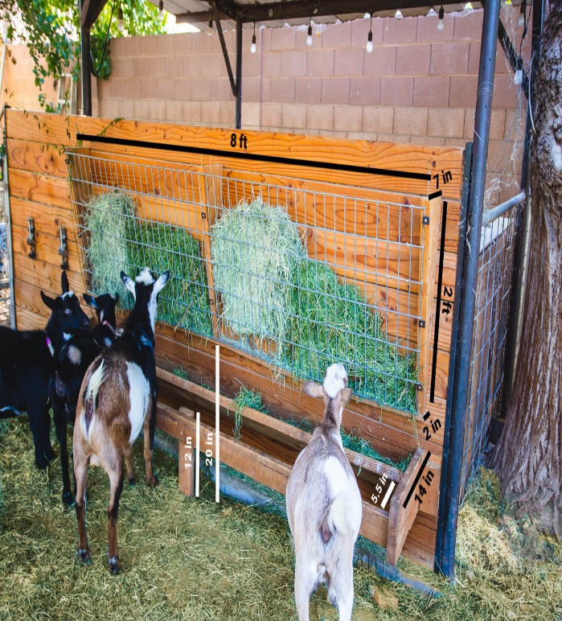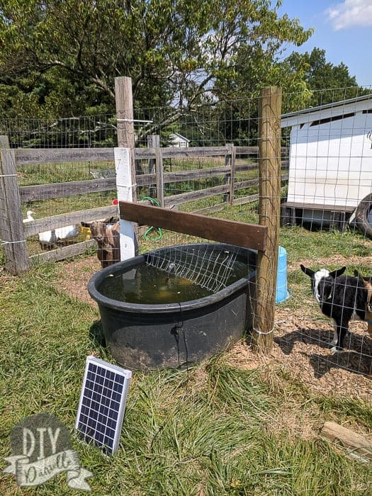

Feed
Pasture, forbs and browse
Pasture, forbs, and browse are usually the primary and most economical source of nutrition for sheep and goats
GRASSES | LUGUMES | SHRUBS
Guinea grass (Panicum spp) | Stylosanthes spp | Cajanus cajan
Buffel grass (Cenchrus ciliaris) | Centrosema pubescens | Leucaenea lucocephala
Elephant grass (pennisetum purpurum) | Pueraria phaseoloides | Gliricidia sepium
Gamba grass (Andropogon gayanus) | Dolichus lablab | Acacia albida
Bracharia (Bracharia mutica)

Elephant grass (Pennisetum purpurum) Guinea grass (pannicum maximum)
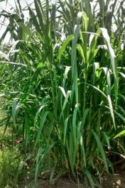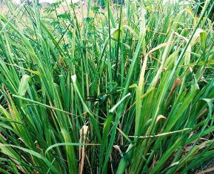
Albizia Leucaenea
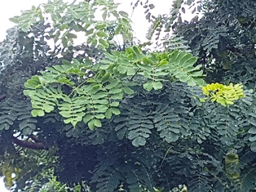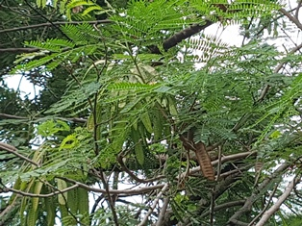

Vaccinations
Vaccine (50 doses) | AGE | FREQUENCY
Pest des pestis ruminant (PPR) | 3 months above | Once in a year
Foot and Mouth Disease (F.M.D) | 4 months above | Twice in a year (September and March)
Anthrax |  | Once in a year

Other medications
Disinfectants | frequency
Omnicide (750mls | 3 times a year
Antibiotics
Penstrep (100mls) | 3 times a year
Oxtetracycline (100mls) | 3 times a year
Sulfadimidine (100mls) | 3 times a year
Multivitamin (100mls) | 3 times a year
Ivermectin (100mls) | 2 times a year
Albendazole (100mls) | 3 times a year
Salt lick

PRODUCTION CYCLE OF SHEEP RUMINANTS
Activity | Sheep
1. Appearance of fist oestrus [months] | 5-10
2. Suitable for breeding/Maturity [months] | 7-12
3. Length of oestrus [days] | 15-19
4. Duration of 0estrus/heat [hours] | 18-24
5. Time of ovulation | 25-30
6. Gestation period [days/months | 145-155days or 5months
7. Number of offspring/litter size  8. Sex ratio | 1-3  1:15 or less

From the production cycle of sheep, the maturity age of sheep is 7 months, which means; it can be sole to the market or cross for breeding. Again, the litter size of sheep suggested that, sheep can give birth to more than one kid. As a starter, I will obtain the starter stock from a reliable source of sheep farm where there are records of animals given birth to more than one kid.
In the first year of production, the sheep can deliver up to 15 kids or more. This bring the total stock to 30 or more sheep. At least, the first year of production, you can sell 15 sheep as your revenue and you still have more than 15 sheep for breed in the second year. Per the maturity age of sheep (7 months), in two years you can have three crosses. Your second year revenue will be improved since you have more sheep to sell.
Again, the demand of sheep in Mampong is very high for both breeding and consumption. One is expected to have a better revenue after keeping the sheep for a while. During festivities (Christmas, New Year, Eidul fitr etc), the demand always surpass the supply and cause high prices of sheep in the market aside inflation. This has been a problem in Mampong with regards to the demand of sheep.
Attach is a budget for 15 sheep for a start-up breed. I will be glad if funds can be raised to support me to bring my dream to reality.

THANK YOU!

